

**DEPARTMENT: ICT**

**PROGRAM: INFORMATION TECHNOLOGY**

**RQF LEVEL: 8**

**Module: cybersecurity**

**Topic: check the practice on googleclass LU5:Assignment /Auditing**

**Correct missing content as hash checker and report**

**Name: NIYIGABA CLAUDE**

**Reg NO: 24RP14647**

**2024-2025**

**check the practice on googleclass LU5:Assignment /Auditing and submit it not later than 3pm today.**

Report on Router attack

As cybersecurity officer, convey the security audit on router that has been attacked

and the configuration modified. Make a report as follows:

1. Use the packet tracer to provide two files: one is backup of configuration file,

second is the current configuration file.

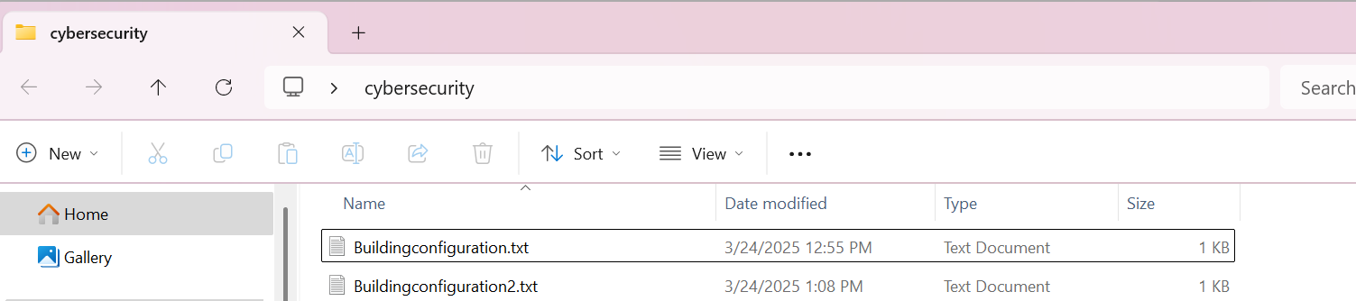

First router code

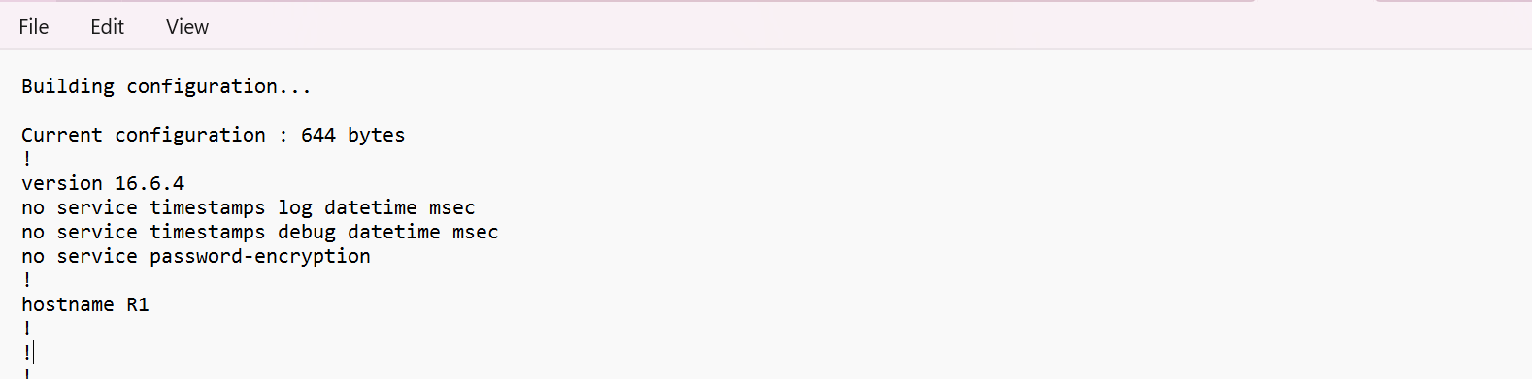

Second router script

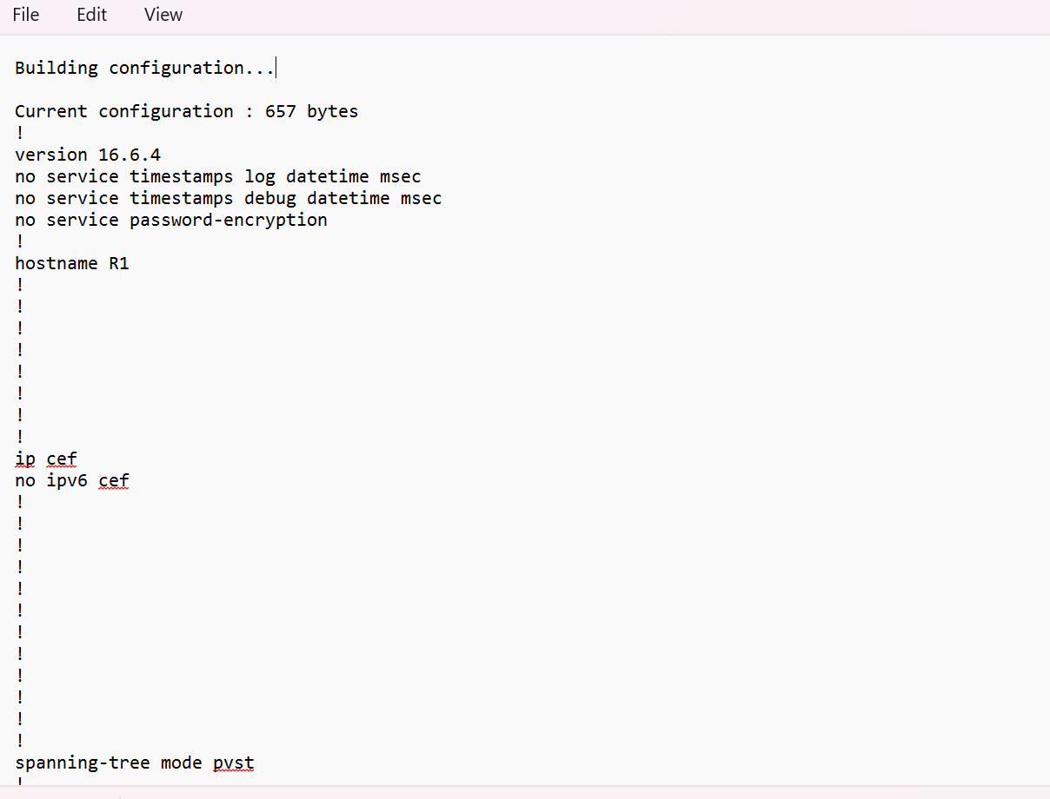

2. Compare the two hashing value files with Hashmyfiles and hash checker tools and

provide the screenshot as evidence.

* This image it show hashmyfile between Buildingconfiguration2 and Buildingconfiguration

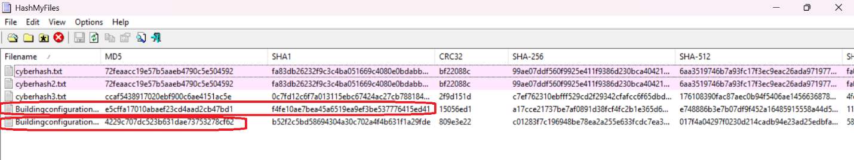

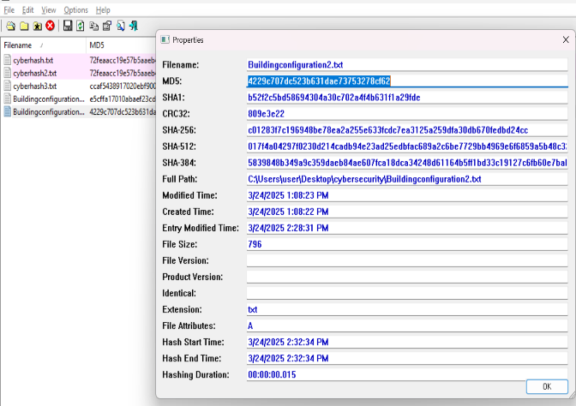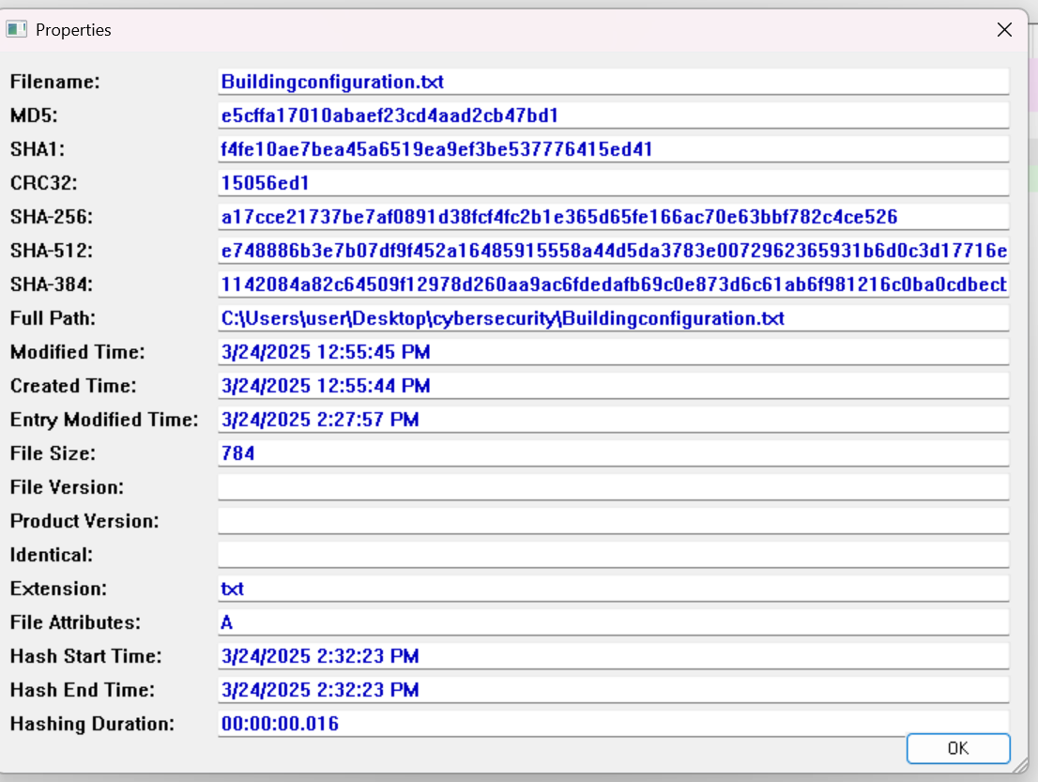

3. Compare the two plain text content files with Hashmyfiles and winmerge tools and

provide the screenshot as evidence.

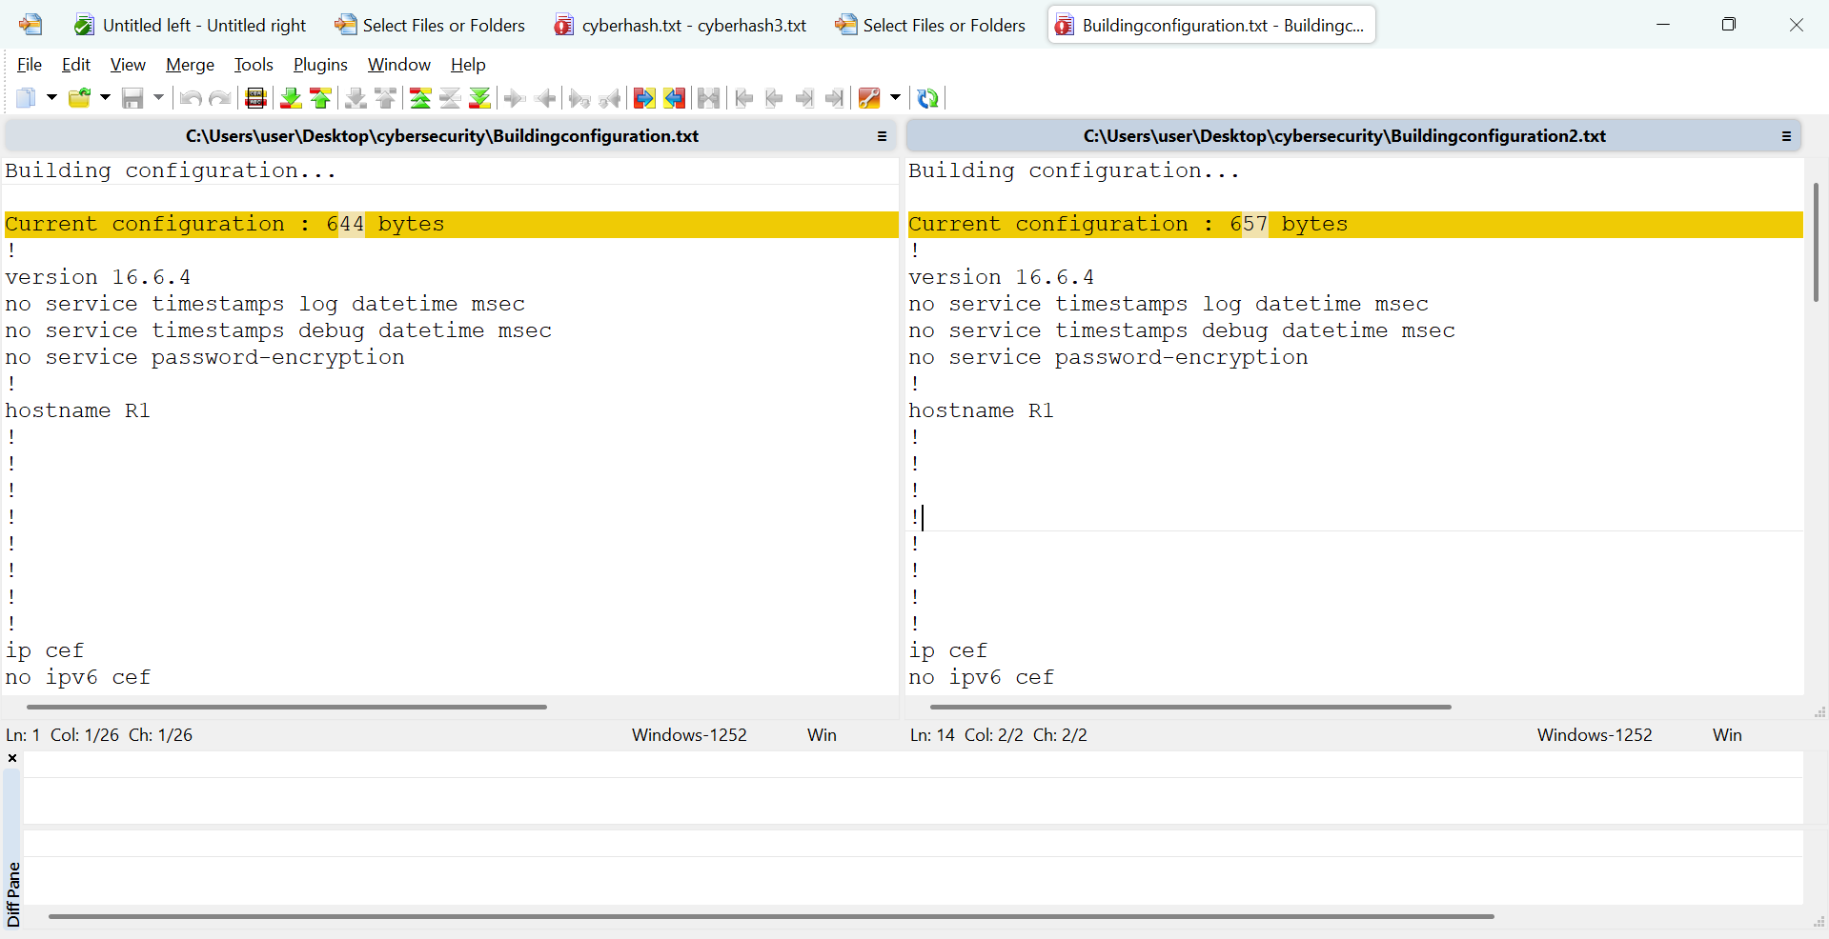

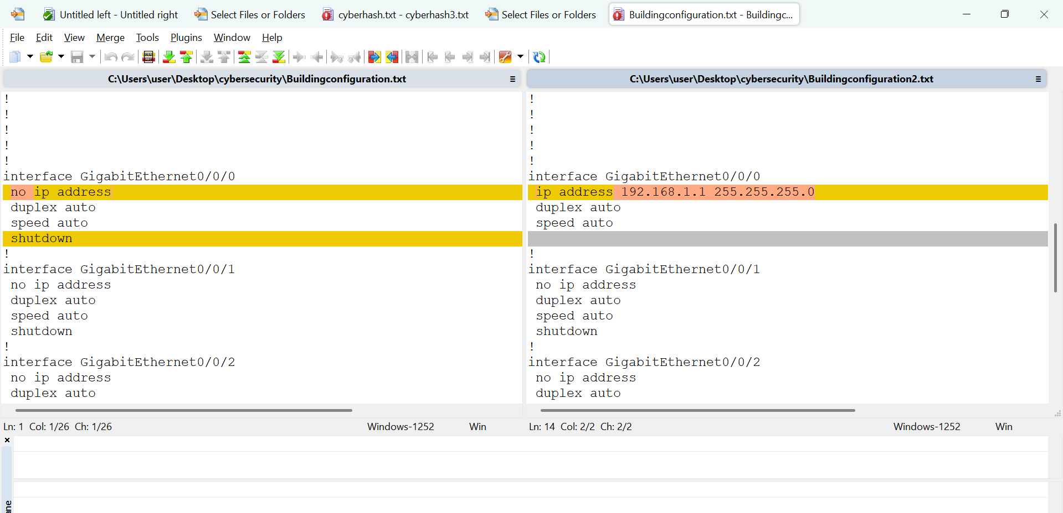

* This image it show hash checker between Buildingconfiguration and Buildingconfiguration2

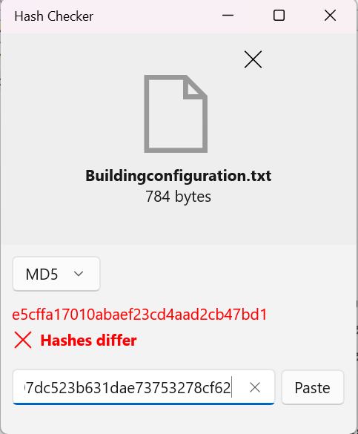

4. Remember to satisfy the attack report with a table which clarifies the modification

made , date and times.

**File Integrity Report**

**Date:** March 24, 2025  
**Location:** C:\Users\user\Desktop\cybersecurity\

### **Overview**

This report details the integrity and modification history of two text files: Buildingconfiguration.txt and Buildingconfiguration2.txt. The analysis includes file metadata, hash values for integrity verification, and modification timestamps.

### **File Details**

| **Attribute** | **First File (Buildingconfiguration.txt)** | **Second File (Buildingconfiguration2.txt)** |
| --- | --- | --- |
| **MD5 Hash** | e5cffa17010abaef23cd4aad2cb47bd1 | 4229c707dc523b631dae73753278cf62 |
| **SHA1 Hash** | f4fe10ae7bea45a6519ea9ef3be537776415ed41 | b52f2c5bd58694304a30c702a4f4b631f1a29fde |
| **Full Path** | C:\Users\user\Desktop\cybersecurity\Buildingconfiguration.txt | C:\Users\user\Desktop\cybersecurity\Buildingconfiguration2.txt |
| **File Extension** | .txt | .txt |
| **File Size (bytes)** | 784 | 796 |
| **Created Time** | 3/24/2025 12:55:44 PM | 3/24/2025 1:08:22 PM |
| **Modified Time** | 3/24/2025 12:55:45 PM | 3/24/2025 1:08:23 PM |
| **Entry Modified Time** | 3/24/2025 2:27:57 PM | 3/24/2025 2:28:31 PM |
| **Hashing Start Time** | 3/24/2025 2:32:23 PM | 3/24/2025 2:32:34 PM |
| **Hashing End Time** | 3/24/2025 2:32:23 PM | 3/24/2025 2:32:34 PM |
| **Hashing Duration** | 00:00:00.016 | 00:00:00.015 |

### **Analysis and Observations this two file**

1. **Integrity Check**: The MD5 and SHA1 hashes indicate that Buildingconfiguration2.txt is different from Buildingconfiguration.txt*,* suggesting content modifications.
2. **File Size Variation**: The second file is slightly larger (796 bytes vs. 784 bytes), indicating additional data or modifications.
3. **Modification Timestamps**: The second file was created and modified later than the first file.
4. **Hashing Consistency**: The hashing duration for both files is nearly identical, confirming consistent computation.

### **Conclusion**

The files have undergone modifications, as reflected in their differing hash values and timestamps. Further analysis should be conducted to compare the content changes between the two versions and assess if unauthorized modifications have occurred.

### **Recommendations**

* Perform a content comparison to identify specific modifications.
* Implement version control to track changes effectively.
* Use digital signatures to verify file authenticity over time.
* Consider automated monitoring tools for real-time file integrity checks.